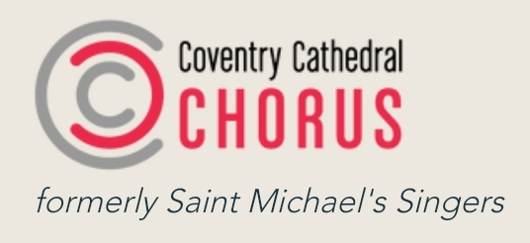

Patrons’ Membership Form - please copy and paste the pro forma below, emailing Rachel Cliffe. patrons@coventrycathedralchorus.com

Name:

Address:
Telephone number:
Email address:
How did you hear about us?:
I agree to set up an annual standing order for a minimum of £25.00.
Signature: ___________________________
Coventry Cathedral Chorus bank details:
Account number: 10034855
Sort code: 163019

